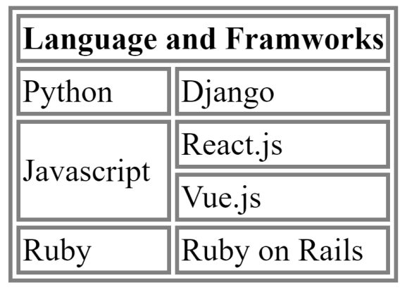

<!DOCTYPE *html*>

<html *lang*="en">

<head>

    <meta *charset*="UTF-8">

    <meta *name*="viewport" *content*="width=device-width, initial-scale=1.0">

    <title>Courses Details</title>

    <style>

        table

        {

            font-size: 30px;

            font-family: Arial;

        }

    </style>

</head>

<body>

    <table border="5" *width*="80%">

        <tr>

            <th *colspan*="2">Language and FrameWorks</th>

        </tr>

        <tr>

            <td>Python</td>

            <td>Django</td>

        </tr>

        <tr>

            <td *rowspan*="2">JavaScript</td>

            <td>React.Js</td>

        </tr>

        <tr>

            <td>Vue.Js</td>

        </tr>

        <tr>

            <td>Ruby</td>

            <td>Ruby on Rails</td>

        </tr>

    </table>

</body>

</html>

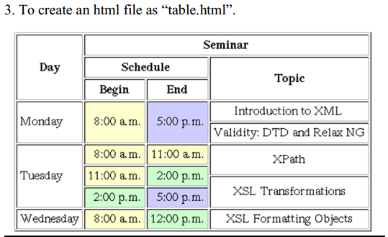

<!DOCTYPE *html*>

<html *lang*="en">

<head>

    <meta *charset*="UTF-8">

    <meta *name*="viewport" *content*="width=device-width, initial-scale=1.0">

    <title>Courses Details</title>

    <style>

        table

        {

            font-size: 30px;

            font-family: Arial;

        }

    </style>

</head>

<body>

    <table border="5" *width*="100%" *cellpadding*="10">

        <tr>

            <th *rowspan*="3">Day</th>

            <th *colspan*="3">Seminar</th>

        </tr>

        <tr>

            <th *colspan*="2">Schedule</th>

            <th *rowspan*="2">Topic</th>

        </tr>

        <tr>

            <th>Begin</th>

            <th>End</th>

        </tr>

        <tr>

            <td *rowspan*="2">Monday</td>

            <td *rowspan*="2">8:00 am</td>

            <td *rowspan*="2">5:00 pm</td>

            <td>Introduction to XML</td>

        </tr>

        <tr>

            <td>Validity:DTD and RelaxNG</td>

        </tr>

        <tr>

            <td *rowspan*="3">TuesDay</td>

            <td>8:00am</td>

            <td>11:00am</td>

            <td *rowspan*="2">XPath</td>

        </tr>

        <tr>

            <td>11:00am</td>

            <td>2:00pm</td>

         </tr>

        <tr>

            <td>2:00pm</td>

            <td>5:00pm</td>

            <td>XSL Tansformations</td>

        </tr>

        <tr>

           <td>WednesDay</td>

           <td>8:00am</td>

           <td>12:00pm</td>

           <td>XSL Formatting Objects</td>

        </tr>

    </table>

</body>

</html>

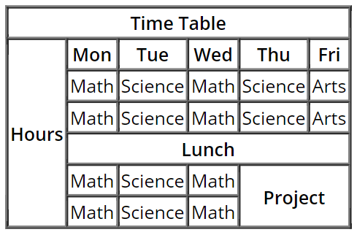

<!DOCTYPE *html*>

<html *lang*="en">

<head>

    <meta *charset*="UTF-8">

    <meta *name*="viewport" *content*="width=device-width, initial-scale=1.0">

    <title>Courses Details</title>

    <style>

        table

        {

            font-size: 30px;

            font-family: Arial;

        }

    </style>

</head>

<body>

    <table border="2" *width*="80%">

        <tr>

            <th *colspan*="6">Time Table</th>

        </tr>

        <tr>

            <th *rowspan*="6">Hours</th>

            <th>Mon</th>

            <th>Tue</th>

            <th>Web</th>

            <th>Thu</th>

            <th>Fri</th>

       </tr>

        <tr>

            <td>Maths</td>

            <td>Science</td>

            <td>Maths</td>

            <td>Science</td>

            <td>Arts</td>

        </tr>

        <tr>

            <td>Maths</td>

            <td>Science</td>

            <td>Maths</td>

            <td>Science</td>

            <td>Arts</td>

        </tr>

        <tr>

            <td *colspan*="5" align="center">Lunch</td>

        </tr>

        <tr>

            <td>Maths</td>

            <td>Science</td>

            <td>Maths</td>

            <td *rowspan*="2" *colspan*="2">Project</td>

        </tr>

        <tr>

            <td>Maths</td>

            <td>Science</td>

            <td>Maths</td>

        </tr>

    </table>

</body>

</html>

**HTML form elements**

HTML is used for creating UI (User Interface) for web application.

**What is form?**

A form is container, where end user or client input data and submit this data to backend or another program.

**This form is created using <form> element**

**Syntax:**

**<form action=”URL” method=”Request Method”>**

**</form>**

**What is URL, URI, URN?**

URL stands for Uniform Resource Location

URI stands for Uniform resource Identification

URN stands for Uniform Resource Name

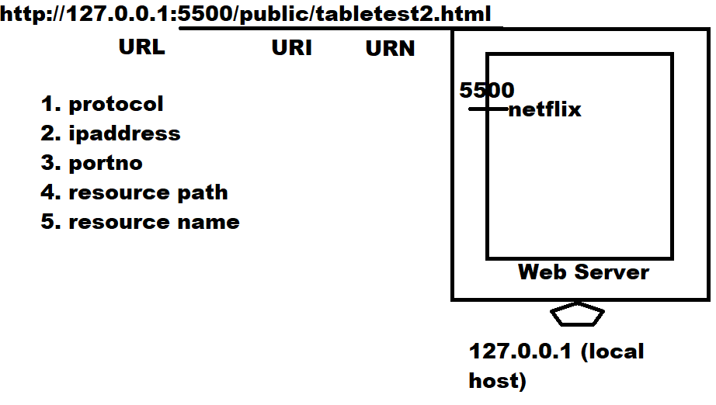

**action**

Action is event which is executed when end user click on submit button.

When end user click on submit button form data is submitted to resource given in action.

**Method**